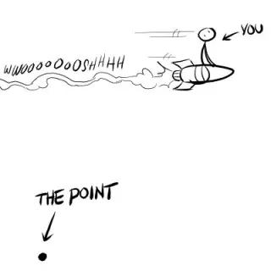
RADICAL ACCEPTANCE

Acceptance: acknowledging the facts are true, conceding the facts
Radical acceptance: with all your mind, body and spirit, fully accepting reality.

- What has to be accepted?
Reality is what it is. We do not have to accept distortions, exaggerations.
Everyone’s future has limitations. Accepting these limitations avoids disappoints.
Everything in the universe has a cause. We don’t need to find the causes.
Life can be worth living even with pain. Acceptance means finding a way to say life is not a catastrophe.

- Why accept reality?

Rejecting or denying reality doesn’t change reality. We can avoid, or reject reality, but it’s still there.

Changing reality requires first accepting reality. Rejecting reality creates a fog where we then can’t see reality and if we don’t see it clearly, then we can’t change it.

Pain cannot be avoided. It is nature’s way of signalling something is wrong.

Rejecting reality turns pain into suffering. When we cannot accept pain, we create suffering. Radical acceptance turns unbearable suffering into bearable pain.

Freedom from painful emotions. Bitterness anger sadness shame is usually replaced by a deeper sense of calm.

Sense of calm. Radical acceptance helps us reach a deep sense of calm so we can move on with our lives.

The path out of hell is through misery. If we refuse to accept the misery that it takes to for us to pass through hell, we fall back and then have to go through the misery again and again until and if we do move beyond hell.

Practising Radical Acceptance
Step by Step.

  - Are you fighting reality? Acknowledging that you are not accepting reality is the first and central step.

  - Accept that reality is just what it is. Use phrases like, ‘everything is as it should be’ or ‘every day is a good day’ to remind ourselves of this.

  - Causes of the reality to accept. Understanding the causes of the reality can help us accept reality. Sometimes we need to look deep inside ourselves to do this.

  - Accept with mind, body and spirit. Accept all the way. Mindfulness is a way to practise acceptance of the moment.

  - Practice opposite action. Act as if you have already radically accepted something, as if you are already that person: your beliefs will become your thoughts, you thoughts will become your actions.

  - Cope ahead. Often difficulties in accepting something is because we fear the truth will be a catastrophe. Identify our emotional needs and what we need to do to satisfy them.

  - Attend to body sensations. Listen to the messages our body sends us. Scan your body and read what it tells us. Consciously address these messages. Adopt a curious mind as you allow yourself to begin to accept.

  - Allow your disappointment, sadness and grief to be there and feel these emotions. Recognise that although you may feel these hard emotions, life is still worth living, acknowledge this. With compassion to yourself, try to let go of resistance, and accept.

  - Do pros and cons. This is a way you can motivate yourself towards acceptance and radical acceptance.

